Project Design Phase-II
Data Flow Diagram & User Stories
Date | 19 October 2026
Team ID
Project Name | Medical Diagnostic Test Center Service Portal(ServiceNow)
Maximum Marks | 4 Marks

Data Flow Diagrams:
A Data Flow Diagram (DFD) shows how information moves through the Medical Diagnosis Center Service Portal, how diagnostic booking requests are processed, and where booking and report records are stored. The Level 0 DFD below summarizes the patient booking workflow.
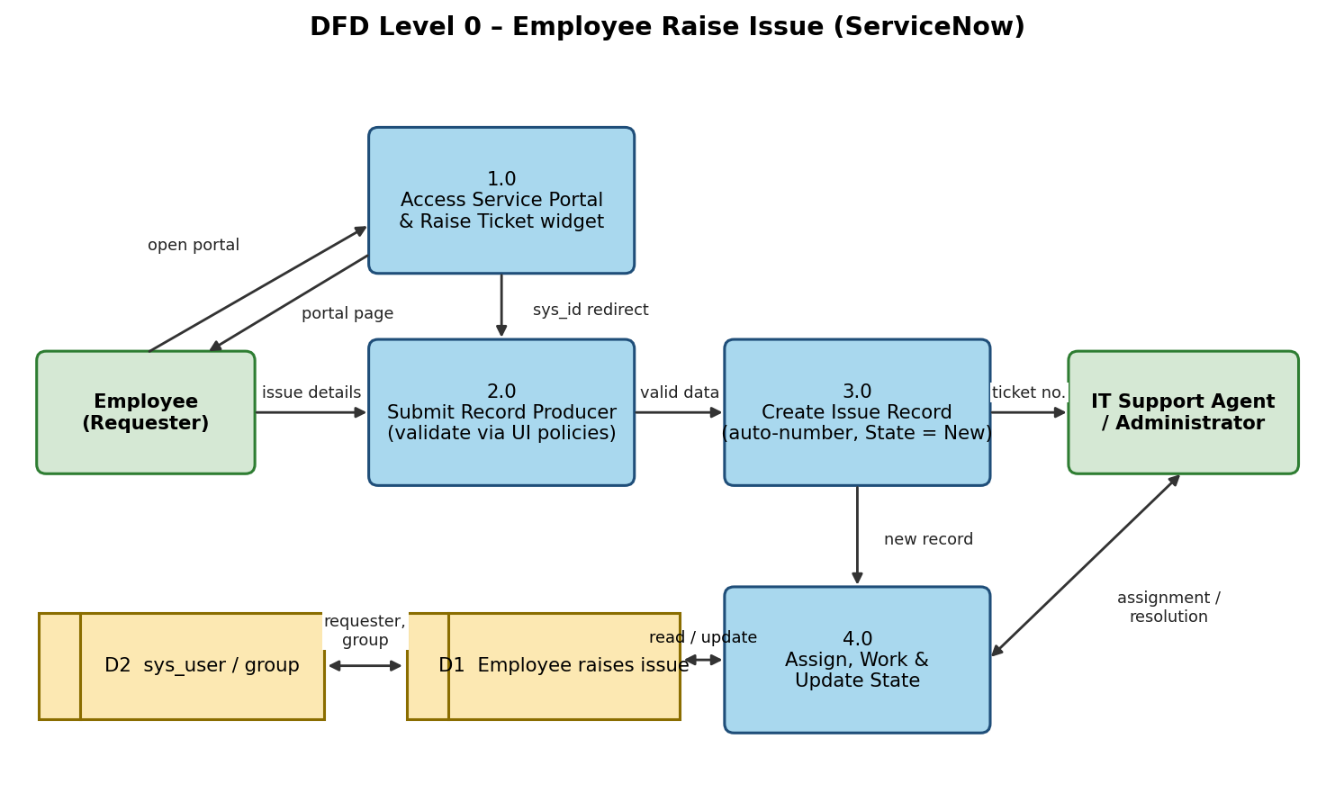
Flow summary: (1) The patient opens the Service Portal and submits a diagnostic test booking request; (2) the system validates the required details; (3) a booking record is created in the diagnostic booking table; (4) authorized lab staff review and update the booking status; (5) the patient checks the booking status and accesses the report when it is available.
User Stories
Use the table below to list the essential user stories for the Medical Diagnosis Center project.
User Type | Functional Requirement (Epic) | User Story Number | User Story / Task | Acceptance criteria | Priority | Release
Patient (Portal user) | Access Portal | US-1 | As a patient, I can open the Medical Diagnosis Center portal and view the available diagnostic services. | Portal page loads and displays the relevant service and navigation options. | High | Sprint 1
 |  | US-2 | As a patient, I can submit a diagnostic test booking request with the required details. | Required fields are validated and a booking record is created after submission. | High | Sprint 1
Patient | Booking Status | US-3 | As a patient, I can check the status of my diagnostic test booking. | The latest status associated with the booking is displayed to the authorized patient. | High | Sprint 2
Lab Staff | Manage Bookings | US-4 | As lab staff, I can view submitted booking requests and identify tests to process. | Authorized lab staff can view the booking details needed to process each test. | High | Sprint 2
 |  | US-5 | As lab staff, I can update a booking status as it moves through processing. | The updated status is saved and reflected in the booking record. | High | Sprint 2
Patient | Access Reports | US-6 | As a patient, I can access my diagnostic report when it is available. | The report is linked to the correct booking and accessible only to authorized users. | High | Sprint 3
Administrator / Developer | Configure Application | US-7 | As an administrator, I can configure the application and diagnostic booking table with required fields. | The table contains the fields needed to record and track diagnostic bookings. | High | Sprint 1
 |  | US-8 | As an administrator, I can configure form validation for required booking details. | The form prevents submission when required details are missing. | High | Sprint 1
 |  | US-9 | As an administrator, I can configure role-based access to booking and report records. | Only users with the appropriate roles can view or update protected records. | High | Sprint 2
Lab Staff | Notifications | US-10 | As lab staff, I can notify a patient when a booking status or report availability changes. | The configured notification is triggered by the relevant status or report update. | Medium | Sprint 3
Administrator / Developer | Reporting | US-11 | As an administrator, I can view reports on diagnostic bookings and their statuses. | A report or dashboard summarizes booking records using available fields. | Medium | Sprint 3
Patient | Booking Details | US-12 | As a patient, I can review the details of my submitted booking. | The patient can view the relevant booking details subject to access permissions. | Medium | Sprint 2

